Big O Notation
Big O Notation tells us how the running time of an algorithm grows as the input size (n) increases.

Examples:
Complexity
O(1) - Constant time
O(log n) - Logarithmic
O(n) - Linear
O(n²) - Quadratic
NOTE:
We use Big O to compare algorithms and find which one is faster for large data.

Search Cases
NOTE: if we are searching in liner way(LINEAR SEARCH)
1) Best Case
Element found immediately.
Example:
[10,20,30,40]
Searching 10.

2) Average Case
Element found somewhere in the middle.
Example:
[10,20,30,40]
Searching 30.
3)Worst Case
Element is last element or not present.
Example:
[10,20,30,40]
Searching 40.

Time Complexity Comparison
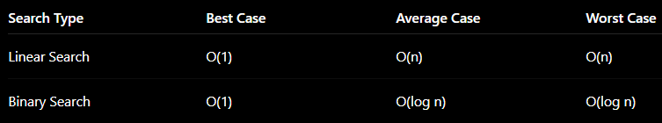
Which is Better for an E-commerce Platform?
Linear Search
Checks products one by one.
Slow for large datasets.
Complexity = O(n).
Binary Search
Repeatedly divides search space into halves.
Very fast.
Complexity = O(log n).
Conclusion
For an e-commerce platform:
- Binary Search is more suitable because it is much faster for large product catalogs.
Condition : Products must be stored in sorted order (e.g., sorted by productId).

